Unit 3. “Crime doesn’t pay”

Topic: Crimes. The Law. School rules.
Objectives: 1) to introduce the topic of crime and the law through general discussion,
2) to practise the vocabulary on the topic of crime and the law,
3) to give practice in listening,
4) to give practice in expressing opinion and giving reasons,
5) to give practice in speaking.
Vocabulary: Crime words and verbs
Grammar: Past Simple, Past Continuous
Media resources: Smart Board, DVD-ROM Blockbuster, Express Publishing
Development
Beginning.

- Warming-up activity.
T.: The topic of today’s lesson is “Crime doesn’t pay”. How do you understand the topic?
P.: It refers to the idea that there are no two ways about the crime. You have to abide by the law.
P.: Crime doesn’t give you any advantage because you will be caught and punished.
T.: Yes, you are quite right. This expression is used when you warn people not to get involved in crime.

- Introduction of the lesson.
T.: We are going
- to revise the words on the topic and some grammar material,
- to solve a crime,
- to listen and read about some crimes,
- to speak about good or bad, in your opinion, school rules,

Follow-up.
Activity 1.
T.: These people have all committed crimes. Click, look and listen what they are in jail for.
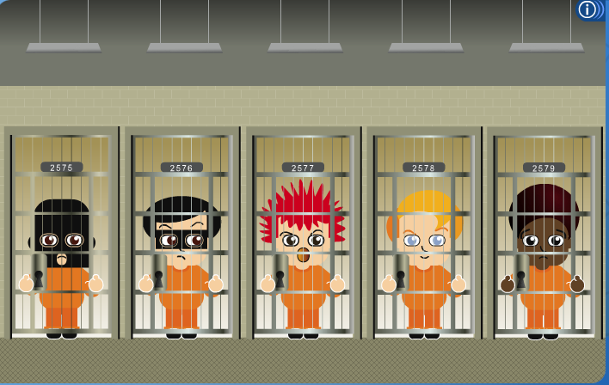
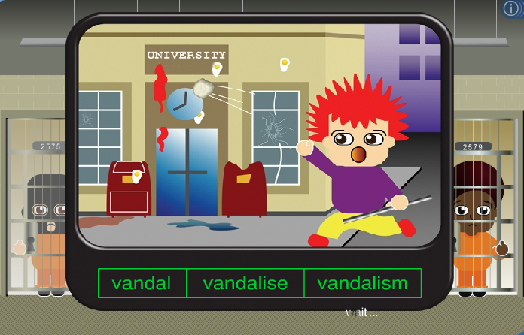

Activity 2.
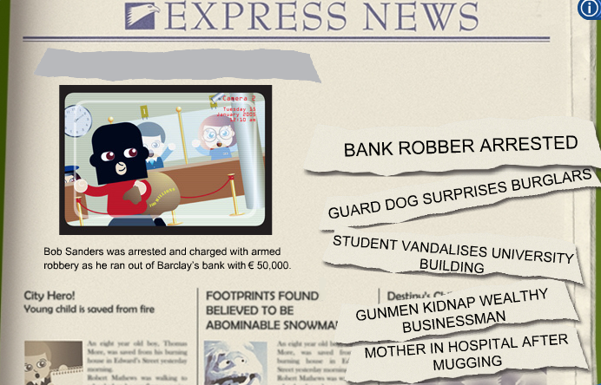
T.: Look, then click and drag the correct headline into place.

Activity 3.
T.: Listen to the definition and give the English word.
Who:
- breaks into homes and robs people (a burglar)
- causes damage to buildings or property (a vandal)
- attacks someone in the street and takes their money (a mugger)
- takes someone away by force (a kidnapper)
- steals from people’s bags or pockets (a pickpocket)
- steals money or goods from a business like a bank or a shop (a robber)
- breaks the law (a criminal)
- sees a crime (a witness)
- is believed to have committed a crime (a suspect)
- is kept in a prison (a prisoner)

Activity 4.
T.: Let’s learn some more new words describing people who help us.
- private investigator
- judge
- bodyguard
- security guard
- police officer
- prison officer
- store detective


Activity 5.
T.: Click on the arrows to complete the picture. Then type each word.

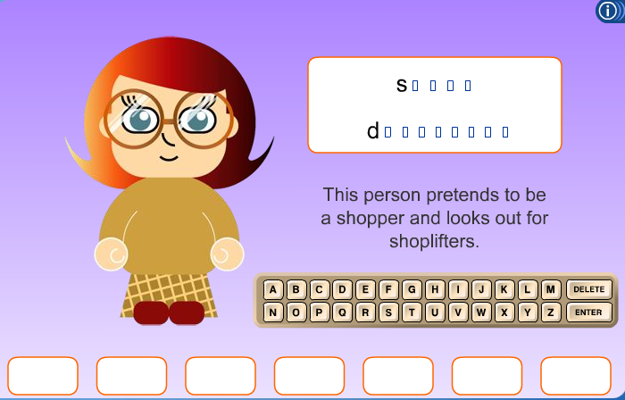

Activity 6.
T.: Do you think it is difficult to solve a crime?
Now I want you to try your skills in investigating a murder.
Look, listen and get ready to answer the questions.

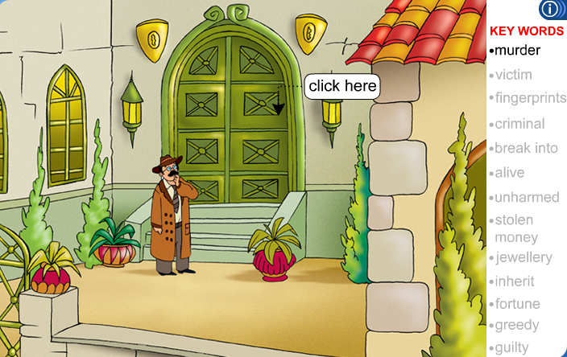

- What is Mr Mills? ( a private detective)
- What is he doing? (He is investigating a murder)
- Who was shot dead? (a millionaire businessman)
- Where was he shot dead? (in his study)
- When was he shot dead? (last night)
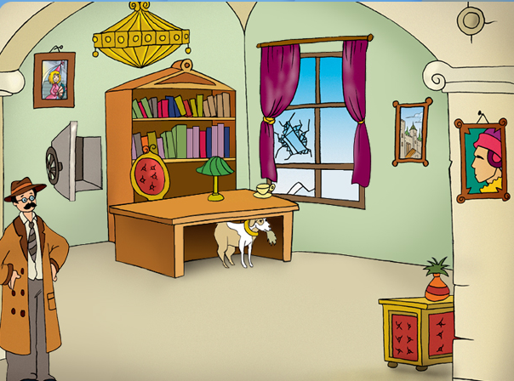

What clues has Mr Mills found?
- The safe is open. Somebody has stolen the money and the jewelry.
- The dog is playing with a piece of torn cloth.
- The window is broken.
- The fingerprints of the victim and the maid are on the cup.

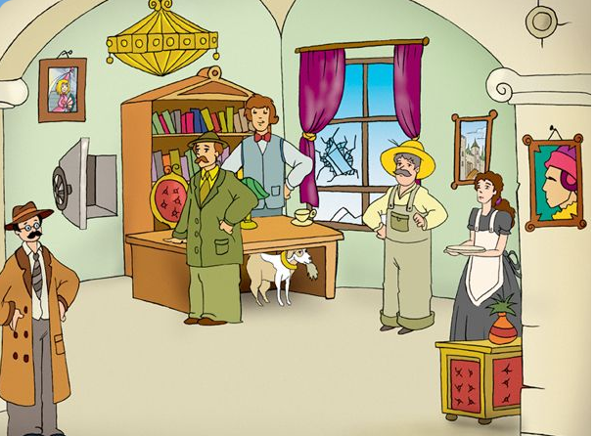

Who are the suspects?
- Mr Charles Sykes’ brother John
- His nephew Richard
- The gardener
- The maid
Who do you think is guilty?

P.: His brother John because he always had money problems and because the gardener heard Mr Charles shouting at John.
P.: No, it can’t be John because Mr Charlse Sykes always helped him with his money problems.
P.: His nephew Richard because he would inherit his fortune.
P.: No, it can’t be Richard because he was out of town on the day of the murder.
P.: His maid because she brought him a cup of tea and went to sleep at midnight.
P.: No, it can’t be the maid because she was devoted to her master and has worked for him for 3 years.
P.: The gardener because his pants are torn and there is a cut on his arm. The maid said the lights were on in his cottage.
P.: No, it can’t be the gardener because he went to sleep at 8 o’clock.

T.: The gardener is guilty.
T.: Now let’s practice the word on the topic.
Look, listen, then click and drag the missing word into place.
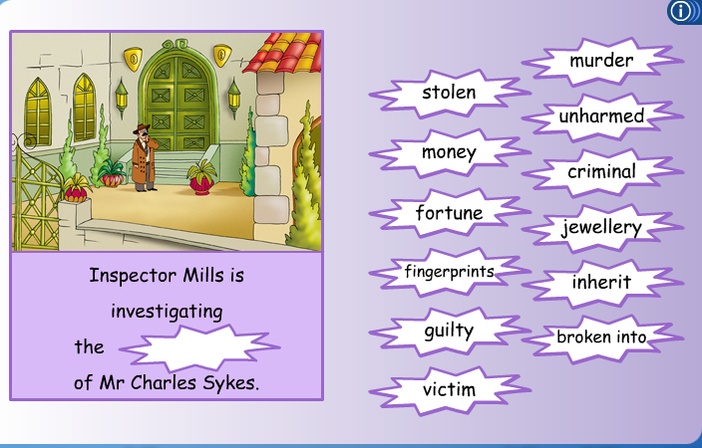

Activity 7.
T.: Let’s revise grammar now. When do we use the Past Continuous tense?
P.: We use the Past Continuous tense when
- two actions happen at the same time in the past
- we describe the setting or give background information to a story
- an action happens at a certain time in the past
- an action was happening in the past
Activity 7.
T.: Read each sentence, then click on the correct prisoner’s cell.
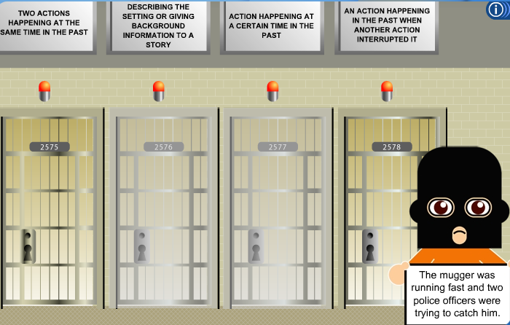

Activity 8.
T.: Fortinately we’ve got no crime at school. But some pupils sometimes break school rules.
What school rules do you know?
What in your opinion are bad or good rules?
What school rules would you like to introduce?

Rounding-off.
T.: Pupils opinion about school rules is quite different. Some pupils want to introduce their own school rules.
Hometask:
T.: At home I want you to prepare some dialogues between a teacher and a pupil who has broken a school rule.

